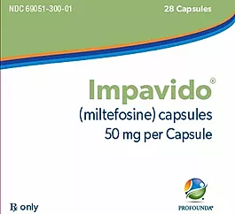

**Primary Amebic Meningoencephalitis (PAM)**

**Contact CDC immediately (24/7) for consultation at the Emergency Operations Center: 770-488-7100**

**Contact Profounda to secure Impavido 24/7 at 908-635-2326**

**What is PAM (primary amebic meningoencephalitis)?**

Naegleria fowleri (commonly referred to as the “brain-eating amoeba” or “brain-eating ameba”), is a free-living microscopic ameba[*](https://www.cdc.gov/parasites/naegleria/index.html#asterisk), (single-celled living organism). It can cause a rare[**](https://www.cdc.gov/parasites/naegleria/index.html#asterisktwo) and devastating infection of the brain called primary amebic meningoencephalitis (PAM). The ameba is commonly found in warm freshwater (e.g. lakes, rivers, and hot springs) and soil. Naegleria fowleri usually infects people when contaminated water enters the body through the nose. Once the ameba enters the nose, it travels to the brain where it causes PAM, which is usually fatal. Infection typically occurs when people go swimming or diving in warm freshwater places, like lakes and rivers. In very rare instances, Naegleria infections may also occur when contaminated water from other sources (such as inadequately chlorinated swimming pool water or heated and contaminated tap water) enters the nose [1-4](https://www.cdc.gov/parasites/naegleria/index.html#one). You **cannot** get infected from **swallowing** water contaminated with Naegleria.

***Disease and Infection:***

PAM is a devastating, rapidly-progressing infection of the brain and spinal cord which begins when ***fresh water*** containing the ameba, Naegleria fowleri, enters the nose and comes into contact with the nasal mucosa.

The ameba penetrates the nasal mucosa, travels along the olfactory nerves, crosses the cribriform plate, and enters the brain.

***Pathogenesis:***

The infection causes a hemorrhagic, necrotizing meningoencephalitis with extensive destruction of cerebral hemispheres, arachnoid and pia mater, and other structures. It results in an overwhelming cerebral edema which causes brain herniation and death. (5,6)

The median time from onset of symptoms to death is 5 days.

The median time from infection to first symptoms is five days.

***Immediate diagnosis and proper treatment is the key to successful outcomes- patient survival with no CNS deficits.***

**In the past 55 years, there have been only 4 survivors of 144 documented PAM cases treated in the United States.**

Misdiagnosis and delayed diagnosis have played a role in many of the fatal outcomes.

In the 2 most recent successful cases, the patients experienced full recoveries with no neurologic deficits.

These successful outcomes were due to early suspicion, in these cases by lab personnel who received CSF and other specimens from a patient with meningitis like symptoms. The lab personnel, then, suspecting PAM, looked for the ameba in the CSF specimen., and then detection of the ameba in the CSF specimen or on a Giemsa-Wright- stained Cytospin slide) diagnosis of the disease when the patient first presents to the ED, combined with aggressive, life-saving treatment.

**What are the symptoms of PAM?**

Symptoms start 1-9 days (median 5 days) after swimming or other nasal exposure to *Naegleria*-containing water. People die 1-18 days (median 5 days) after symptoms begin [4](https://www.cdc.gov/parasites/naegleria/illness.html#four). PAM is difficult to detect because the disease progresses rapidly so that diagnosis is usually made after death [1](https://www.cdc.gov/parasites/naegleria/illness.html#one),[2](https://www.cdc.gov/parasites/naegleria/illness.html#two). Signs and symptoms of the infection include:

Stage 1

* Severe frontal headache

Symptoms appearing ***early*** after infection: non-specific “flu-like prodrome” symptoms

* Headache- often it is sudden-onset, frontal, persistent, and not alleviated with medication
* Nausea/vomiting
* Fever
* Fatigue
* Earache (not as frequent as those above)
* Fever
* Nausea
* Vomiting
* Sensitivity to light
* Sensitivity to touch

Early symptoms appear an average of 5 days after infection, and last for an average of 2 days.

Stage 2

* Stiff neck

Symptoms appearing ***late***: symptoms showing CNS involvement

* Nuchal rigidity
* Lethargy
* Confusion/disorientation
* Anorexia
* Irritation/combativeness
* Photophobia
* Drowsiness
* Seizures
* Blurred vision
* Myalgia
* Abnormal deep tendon reflexes
* Comatose
* Stuporous
* Obtunded
* Abnormal gait/inability to walk
* Syncope
* Hallucinations
* Seizures
* Altered mental status
* Hallucinations
* Coma

From: <https://academic.oup.com/jpids/article/4/4/e68/2580118>

Diagnosis, Clinical Course, and Treatment of Primary Amoebic Meningoencephalitis in the United States, 1937–2013

Linda G. Capewell Aaron M. Harris Jonathan S. Yoder Jennifer R. Cope Brittany A. Eddy Sharon L. Roy Govinda S. Visvesvara LeAnne M. Fox Michael J. Beach

Journal of the Pediatric Infectious Diseases Society, Volume 4, Issue 4, 1 December 2015, Pages e68–e75, <https://doi.org/10.1093/jpids/piu103>

**How is PAM diagnosed?**

Steps for rapid diagnosis and treatment for a successful outcome to PAM

1. Associate meningitis like symptoms with the possibility of PAM
2. Narrow diagnosis of PAM with a positive history of nasal freshwater exposure within the past 14 days.
   1. **Examples of freshwater exposure include: Pools, hotubs, freshwater lakes, Neti-pot use**
3. Labs: with CSF specimen, **include an order** **for detection ofthe ameba, *Naegleria fowleri.*** *(tests are conducted in the hospital lab)* Specific lab procedures are below, under “Diagnosis”, along with a link to the video: “Laboratory Detection of *Naegleria fowleri”.*
4. Contact CDC immediately (24/7) for consultation at the Emergency Operations Center: 770-488-7100.
5. Begin treatment *immediately*, based on the presumptive diagnosis from clinical information, laboratory findings (including positive findings of an ameba in the CSF (per lab steps, below)) and CDC consultation.

There are 4 elements needed for a rapid presumptive diagnosis of PAM, which is critical to a successful outcome: patient survival with no CNS deficits.

1. **Symptoms**

Think: bacterial (or viral) meningitis -like symptoms

The median time from infection to first symptoms is five days.

1. **Positive History**

Has the patient experienced nasal freshwater exposure within the past 14 days?

1. Any activities in natural bodies of freshwater (commonly warm fresh water) where the water could have entered the nasal passages. (lakes, rivers, ponds, streams, etc)
2. Activity in recreational freshwater venues, natural or man-made: e.g. waterskiing/wake boarding cable parks, surfing parks, springs, swimming pools) with untreated, or poorly treated water.
3. Nasal/sinus rinsing or other type of nasal exposure such as bathing with untreated or improperly treated house tap water (Neti pot usage, ritual nasal ablution, etc). There have been cases wherein patients were infected using either poorly treated house tap water or untreated natural sources for bathing or nasal/sinus rinsing.
4. Poorly-treated house tap water used in lawn recreational activities (e.g. lawn waterslide).

Important:

* Remember that the exposure may have occurred at a travel destination before the patient returns home.
* In recent years, infections have occurred in northern states- this disease is now not just a southern tier infection.
* The majority of patients are immunocompetent. Immune compromise is not part of the diagnostic profile for PAM.

**Even with a negative history** of exposure (above) reported by the patient or guardian, PAM should not be ruled out before lab results are in (including those for detection of the ameba), and before consultation with CDC.

1. **Laboratory results and rapid lab detection of the causative agent *Naegleria fowleri***

* 1. CSF and blood drawn for laboratory tests according to diagnostic protocols.
* 2. In addition to these tests, **a specific order should be entered** **for rapid detection of the ameba *Naegleria fowleri* from the CSF specimen.** (Steps and video resource for detection of the ameba use this link <http://www.jordansmelskifoundation.org/lab-detection-naegleria-fowleri>)

**Most common lab results with PAM**

|  |  |
| --- | --- |
| CSF | Blood (CBC) |
| Red blood cells: 265 | White blood cells: 16.8 x 103 |
| White blood cells: 2,400 | % Lymphocytes: 4 |
| % lymphocytes: 15 | % neutrophils: 87 |
| Percent neutrophils: 83 | % bands: 8 |
| Percent monocytes: 8 | % monocytes: 4 |
| Glucose: 23 | Hemoglobin: 13 |
| Protein 365 | Hematocrit: 39 |
| Opening pressure: 385 | Platelets: 288 |

From: <https://academic.oup.com/jpids/article/4/4/e68/2580118>

Diagnosis, Clinical Course, and Treatment of Primary Amoebic Meningoencephalitis in the United States, 1937–2013

Linda G. Capewell Aaron M. Harris Jonathan S. Yoder Jennifer R. Cope Brittany A. Eddy Sharon L. Roy Govinda S. Visvesvara LeAnne M. Fox Michael J. Beach

Journal of the Pediatric Infectious Diseases Society, Volume 4, Issue 4, 1 December 2015, Pages e68–e75, https://doi.org/10.1093/jpids/piu103

**In-House Lab Detection**

**Steps for “in-house” lab detection of the ameba *Naegleria fowleri in CSF:***

(at 32:00 in the video: Lab Detection of *Naegleria fowleri* [*http://www.jordansmelskifoundation.org/lab-detection-naegleria-fowleri*](http://www.jordansmelskifoundation.org/lab-detection-naegleria-fowleri))

There are two methods for lab detection of the ameba in the hospital lab; it is recommended that ***both*** of these methods be undertaken simultaneously.

***Fresh, unfrozen, unrefrigerated*** CSF is used in both bold methods:

1. Direct visualization of motile amebae, and
2. Wright staining (on Cytospin slide)

GRAM STAINING IS NOT USED- IT DESTROYS THE AMEBA AND RENDERS IT VIRTUALLY IMPOSSIBLE TO DETECT

Method 1: Direct Visualization of the motile ameba:

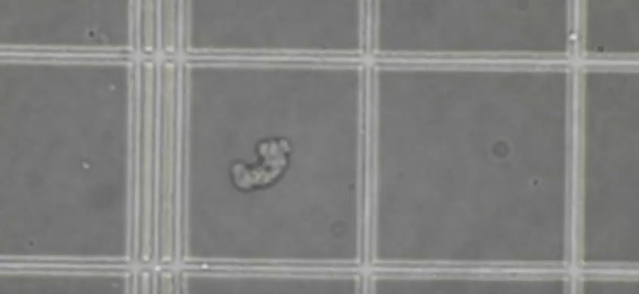

*Naegleria fowleri* in counting chamber (direct mount, CSF)

From the video: “LAB Detection of *Naegleria fowleri*” : http://www.jordansmelskifoundation.org/lab-detection-naegleria-fowleri

The ameba varies in size from about 15 µm to about 30-35 µm. It moves rapidly (~1 µm/s) and sinuously in a generally linear forward direction. See the movement at 32:50 of the video.

Prior to the steps below, warm the aliquot of CSF to 35°C in an incubator or water bath for a few minutes. (A phase-contrast microscope is recommended)

1. Direct wet mount:

Using an aliquot of the warmed CSF:

1. Charge a counting chamber. Allow the counting chamber to sit on the microscope stage for a few minutes to warm the fluid before looking for the ameba.

Or:

1. Using a plain glass slide, place a drop of well-mixed CSF on the slide, and allow a few minutes for the fluid to warm before looking for the ameba.

If the ameba or amebae are not identified during the first step above, proceed to step 2.

1. Centrifuge prior to looking: If the step above does not reveal the ameba, centrifuging an aliquot of the fresh, unfrozen, unrefrigerated CSF may result in detection.

***Performing both procedures (direct wet mount and centrifuge prior to looking) simultaneously*** would be the best approach**.**

1. Spin an aliquot of CSF at 2,000 RPMs in a standard centrifuge for 5 minutes. Place a drop of the sediment on a slide as above (1). Spinning the aliquot at a higher rate will result in destruction of the ameba and motility therefore would not be observed.

Notes for both steps:

The ameba can easily be mistaken for an artifact or even a macrophage, especially if it is moving very slowly or not at all. Study all cell-like material for movement, and the entire slide or chamber should be studied. Take time to look well.

Photos or a video may be helpful, especially when consulting with CDC during the diagnostic process.

Consultation with CDC, which should be initiated immediately upon suspicion in the ED, includes help with interpretation and visualization during the steps above.

Periodic acid-Schiff (PAS) and trichrome stains can also be used on CSF smears, however these were not used in the 2 most recent successful case outcomes.

Step 2. Giemsa-Wright staining on Cytospinned slide.

Stain the Cytospinned slide with Giemsa-wright stain. Carefully study the slide for the ameba, using the information directly above.

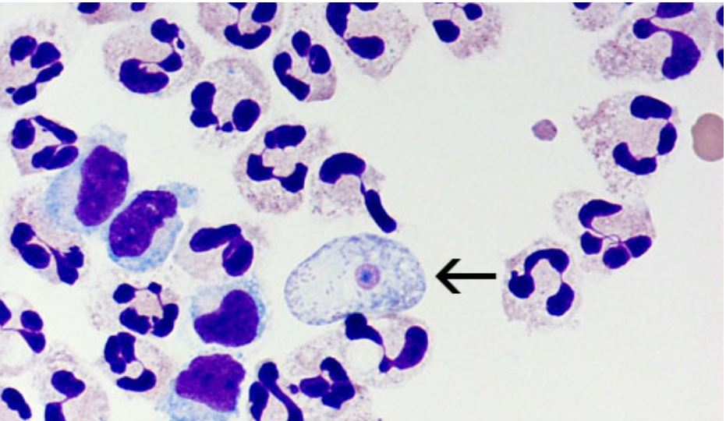

*Naegleria fowleri* (arrow) on Giemsa-Wright stain of fixed CSF Magnification of X 1000

Centers for Disease Control and Prevention (CDC) https://www.cdc.gov/parasites/naegleria/naegleria-fowleri-media.html

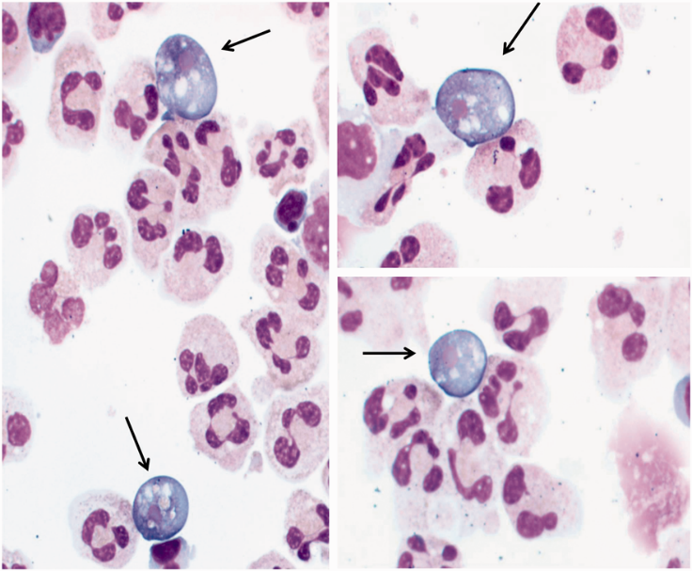

The ameba will have a light blue cytoplasm and violet nucleus with a dark blue nucleolus.

*Naegleria fowleri* (arrows) on Wright-Giemsa stained cerebrospinal fluid cytospin slides (original magnification, ×1000; oil immersion).

From: <https://academic.oup.com/labmed/article/47/2/149/2937887>

Naegleria fowleri That Induces Primary Amoebic Meningoencephalitis: Rapid Diagnosis and Rare Case of Survival in a 12-Year-Old Caucasian Girl

Andrew L. Dunn, MD Tameika Reed, MT (ASCP) Charlotte Stewart, MT (ASCP) Rebecca A. Levy, MD

Laboratory Medicine, Volume 47, Issue 2, 1 May 2016, Pages 149–154, https://doi.org/10.1093/labmed/lmw008

In the successful case outcome in 2013 FN the 2 Arkansas articles, the ameba was not detected by the direct visualization steps above, but by an examination of the Giemsa-Wright stained Cytospin slide.

**Treatment**

Treatment should be initiated immediately after the presumptive diagnosis, and in consultation with CDC (24/7 Emergency Operations Center at 770-488-7100).

***Urgency in treatment:***

The median time from onset of symptoms to death is 5 days. **Unlike most other infections seen in the United States at this time, this infection progresses so rapidly, that it is fatal without immediate and heroic, intense efforts from multiple specialties.**

The usual paradigm with certain diseases of delaying treatment, despite a presumptive diagnosis in the hospital, until outside confirmatory lab results are returned, will not work in the best interest of the patient, the physicians, and the hospital in PAM cases.

The confirmatory lab result: In addition to the invaluable emergency consultation service that CDC provides, the waterborne disease prevention branch will also conduct a PCR lab confirmatory test for the ameba, from a submitted CSF specimen. The results for the confirmatory test will generally take 48-72 hours including shipping time to the laboratory in Atlanta as well as the time taken to actually run the test.

The healthcare providers involved in a PAM case should decide, in consultation with CDC, as to whether it will be in the best interest of all to delay treatment (with a presumptive diagnosis “in-hand”), until test results from CDC are made available to the hospital, or to begin treatment immediately.

The three components to treatment in the most recent documented successful case were:

1. Medication regimen including Impavido®(miltefosine), and
2. Neuroprotective management principles for traumatic brain injury.
3. Physical therapy
4. The recommended medication regimen is:

|  |  |  |  |  |  |
| --- | --- | --- | --- | --- | --- |
| Drug | Dose | Route | Maximum dose | Duration | Comments |
| Amphotericin B* | 1.5 mg/kg/day in 2 divided doses | IV | 1.5 mg/kg/day | 3 days |  |
| Then | 1 mg/kg/day once daily | IV |  | 11 days | 14-day course |
| Amphotericin B | 1.5 mg once daily | Intrathecal | 1.5 mg/day | 2 days |  |
| Then | 1 mg/day every other day | Intrathecal |  | 8 days | 10-day course |
| Azithromycin | 10 mg/kg/day once daily | IV/PO | 500 mg/day | 28 days |  |
| Fluconazole | 10 mg/kg/day once daily | IV/PO | 600 mg/day | 28 days |  |
| Rifampin | 10 mg/kg/day once daily | IV/PO | 600 mg/day | 28 days |  |
| Impavido®  (Miltefosine) | Weight <45 kg: 50 mg BID  weight> 45 kg: 50 mg TID | PO | 2.5 mg/kg/day | 28 days | 50 mg capsules |
| Dexamethasone | .6 mg/kg/day in 4 divided doses | IV | .6 mg/kg/day | 4 days |  |

* Conventional amphotericin (AMB) is preferred. When AMB was compared with liposomal AMB against Naegleria fowleri, the minimum inhibitory concentration (MIC) for AMB was 0.1 µg/mL, while that of liposomal AMB was 10x higher at 1 µg/ml.

From: <https://www.cdc.gov/parasites/naegleria/treatment-hcp.html>

1. Aggressive management of the intracranial pressure (ICP) and cerebral perfusion pressure (CPP) from edema using the neuroprotective management treatment principles for traumatic brain injury. Rapidly increasing ICP from cerebral edema produced by the infection that is not overcome is the ultimate cause of death in PAM patients.

Management of cerebral edema:

1. Placement of an external ventricular drain
2. Hyperosmolar therapy, with mannitol and 3% saline
3. Moderate hyperventilation (goal: PaCO2 30 – 35 mm Hg)
4. Induced hypothermia (32° C – 34° C)
5. Establish a goal ICP as well as CPP (in the case managed by Dr. Linam, et al, it was <20 mm Hg, and >60 mm Hg respectively)
6. Physical therapy

From: <https://pediatrics.aappublications.org/content/135/3/e744.long>

Successful treatment of an adolescent with *Naegleria fowleri* primary amebic meningoencephalitis.

Linam WM1, Ahmed M2, Cope JR3, Chu C2, Visvesvara GS3, da Silva AJ3, Qvarnstrom Y3, Green J2.

Pediatrics. 2015 Mar;135(3):e744-8. doi: 10.1542/peds.2014-2292. Epub 2015 Feb 9.

Q & A- Clinical

Q: Where do I get Impavido® for treatment?

A: Your hospital chose to participate in the Profounda consignment program, so Impavido® is ready for immediate use. It is located in this binder at _______________________ in the pharmacy or call 908-635-2326.

Q: How is Impavido administered?

A: Orally.

If the patient is unconscious, Impavido® is administered via nasogastric tube: dissolve the contents of the capsule in distilled water and pour down NG tube

Q: What monitoring should be done during therapy?

A:

* 1. Pressures:

Intracranial pressure (ICP): <20 mm Hg

Cerebral perfusion pressure (CPP): >60 mm Hg

Blood gasses: monitoring moderate hyperventilation: goal PaCO2: 30–35 mm Hg

* 1. Organ systems- response to treatment:

Monitoring organ response to the collective treatment regimen.

* 1. Body temperature during induced therapeutic hypothermia:

32°C–34°C

Specific monitoring values in Q and A are from: <https://pediatrics.aappublications.org/content/135/3/e744>

Q: Is brain CT or MRI useful in diagnosing PAM?

A: **Negative CT and MRI results should *not* be used to rule out PAM.**

Imaging features of amebic meningoencephalitis are nonspecific, particularly early in the course of the disease, and, in fact, within around 1-3 days of symptom onset, may be normal.

However, the picture can change rapidly with subsequent imaging, even 12-17 hours after the initial negative images, with signs of cerebral edema.

As the infection progresses, from around 2 to 4 days post- symptom onset and later, CT and MRI may reveal a nonspecific diffuse cerebral edema pattern and hydrocephalus, including evidence of obliteration of the cisterns with enhancing basilar exudates.

Findings at 4 days post-symptom onset have included:

Obliteration of the basal cisterns, including near effacement of perimesencephalic cisterns with meningeal exudates, thickening of meninges at the superior cerebellar cistern, right basal ganglia infaction, effacement of the cortical sulci and basilar cisterns, leptomeningeal enhancement, decrease in the size of ventricles, areas of hemorrhage or necrosis, and/or herniation.

Imaging information from:

* *Amebic Meningoencephalitis: Spectrum of Imaging Findings*

P. Singh, R. Kochhar, R.K. Vashishta, N. Khandelwal, S. Prabhakar, S. Mohindra and P. Singhi

American Journal of Neuroradiology June 2006, 27 (6) 1217-1221; <http://www.ajnr.org/content/27/6/1217>

* -*CNS infections with free-living amebas: neuroimaging findings.*

D D Kidney and S H Kim, American Journal of Roentgenology. 1998;171: 809-812. 10.2214/ajr.171.3.9725321 <https://www.ajronline.org/doi/abs/10.2214/ajr.171.3.9725321>

* Diagnosis, Clinical Course, and Treatment of Primary Amoebic Meningoencephalitis in the United States, 1937–2013

Linda G. Capewell Aaron M. Harris Jonathan S. Yoder Jennifer R. Cope Brittany A. Eddy Sharon L. Roy Govinda S. Visvesvara LeAnne M. Fox Michael J. Beach

<https://academic.oup.com/jpids/article/4/4/e68/2580118>

**Q&A: Clinical, and Patient questions**

**Q. What is *Naegleria*?**

A. *Naegleria* is an ameba (single-celled living organism) commonly found in warm freshwater (for example, lakes, rivers, and hot springs) and soil. Only one species (type) of Naegleria infects people: Naegleria fowleri.

**Q. How does infection with Naegleria fowleri occur?**

A. *Naegleria fowleri* infects people when water containing the ameba enters the body through the nose. This typically occurs when people go swimming or diving in warm freshwater places, like lakes and rivers. The Naegleria fowleri ameba then travels up the nose to the brain where it destroys the brain tissue.

You cannot be infected with Naegleria fowleri by drinking contaminated water. In very rare instances, Naegleria infections may also occur when contaminated water from other sources (such as inadequately chlorinated swimming pool water or contaminated tap water) enters the nose, for example when people submerge their heads or cleanse their noses during religious practices, and when people irrigate their sinuses (nose) using contaminated tap water. Naegleria fowleri has not been shown to spread via water vapor or aerosol droplets (such as shower mist or vapor from a humidifier).

**Q. Where is *Naegleria fowleri* found?**

A. *Naegleria fowleri* is found around the world. In the United States, the majority of infections have been caused by *Naegleria fowleri* from freshwater located in southern-tier states. The ameba can be found in:

Bodies of warm freshwater, such as lakes and rivers

Geothermal (naturally hot) water, such as hot springs

Warm water discharge from industrial plants

Geothermal (naturally hot) drinking water sources

Swimming pools that are poorly maintained, minimally-chlorinated, and/or un-chlorinated

Water heaters. *Naegleria fowleri* grows best at higher temperatures up to 115°F (46°C) and can survive for short periods at higher temperatures.

Soil

*Naegleria fowleri* is not found in salt water, like the ocean.

**Q. In what water temperature does *Naegleria fowleri* cause infection?**

A. *Naegleria fowleri* is a heat-loving (thermophilic) organism. It grows best at higher temperatures up to 115°F (46°C) and can survive for short periods at higher temperatures. It is less likely to be found in the water as temperatures decline. The ameba can be found in lake or river sediment at temperatures well below where one would find the ameba in the water.

**Q. What is the source of food for *Naegleria fowleri*?**

*Naegleria fowleri* eats other organisms like bacteria found in the sediment in lakes and rivers.

**Q. Can I get a *Naegleria fowleri* infection from a disinfected swimming pool?**

A. No. You cannot get a *Naegleria fowleri* infection from a properly cleaned, maintained, and disinfected swimming pool.

**Q. How common are *Naegleria fowleri* infections in the United States?**

A. *Naegleria fowleri* infections are rare*. In the 10 years from 2008 to 2017, 34 infections were reported in the U.S. Of those cases, 30 people were infected by recreational water, 3 people were infected after performing nasal irrigation using contaminated tap water, and 1 person was infected by contaminated tap water used on a backyard slip-n-slide.

*Rare Disease

There is no universal definition of a “rare disease” but the U.S. Rare Disease Act of 2002 defined a rare disease as affecting less than 200,000 people in the U.S. and this definition has been adopted by the National Institutes of Health, Genetic and Rare Diseases Information Centers.

**Q. When do *Naegleria fowleri* infections most commonly occur?**

A. While infections with *Naegleria fowleri* are rare, they occur mainly during the summer months of July, August, and September. Infections are more likely to occur in southern-tier states, but can also occur in other more northern states. Infections usually occur when it is hot for prolonged periods of time, which results in higher water temperatures and lower water levels.

**Q. Can infection be spread from one person to another?**

A. No. *Naegleria fowleri* infection cannot be spread from one person to another.

**Q. What are the symptoms of *Naegleria fowleri* infection?**

A. *Naegleria fowleri* causes the disease primary amebic meningoencephalitis (PAM), a brain infection that leads to the destruction of brain tissue. In its early stages, symptoms of PAM may be similar to symptoms of bacterial meningitis.

Initial symptoms of PAM start about 5 days (range 1 to 9 days) after infection. The initial symptoms may include headache, fever, nausea, or vomiting. Later symptoms can include stiff neck, confusion, lack of attention to people and surroundings, loss of balance, seizures, and hallucinations. After the start of symptoms, the disease progresses rapidly and usually causes death within about 5 days (range 1 to 12 days).

**Q. What is the actual mechanism of death from *Naegleria fowleri* infection?**

A. The infection destroys brain tissue causing brain swelling and death.

**Q. What is the fatality rate for an infected person who begins to show signs and symptoms?**

A. The fatality rate is over 97%. Only 4 people out of 143 known infected individuals in the United States from 1962 to 2017 have survived.

**Q. Is there effective treatment for infection with *Naegleria fowleri*?**

A. It is not clear. Several drugs are effective against *Naegleria fowleri* in the laboratory. However, their effectiveness is unclear since almost all infections have been fatal, even when people were treated with similar drug combinations. ***Recently, two people with Naegleria infection survived after being treated with a new drug called miltefosine that was given along with other drugs and aggressive management of brain swelling.***

**Q. What should I do if I have been swimming or playing in freshwater and now think I have symptoms associated with *Naegleria fowleri*?**

A. Infection with *Naegleria fowleri* is rare. The early symptoms of *Naegleria fowleri* infection are similar to those caused by other more common illnesses, such as bacterial meningitis . People should seek medical care immediately whenever they develop a sudden onset of fever, headache, stiff neck, and vomiting, particularly if they have been in warm freshwater recently.

**Q. How common is *Naegleria fowleri* in the environment?**

A. *Naegleria fowleri* is commonly found in lakes in southern-tier states during the summer but more recently has caused infections in northern states. This means that recreational water users should be aware that there will always be a low level risk of infection when entering these waters. In very rare instances, *Naegleria* has been identified in water from other sources such as inadequately chlorinated swimming pool water or heated and contaminated tap water. *Naegleria fowleri* grows best at higher temperatures up to 115°F (46°C) and can survive for short periods at higher temperatures.

**Q. Is there a routine and rapid test for *Naegleria fowleri* in the water?**

A. No. It can take weeks to identify the ameba, but new detection tests are under development. Previous water testing has shown that *Naegleria fowleri* is commonly found in freshwater venues. Therefore, recreational water users should assume that there is a low level of risk when entering all warm freshwater, particularly in southern-tier states.

**Q. How does the risk of *Naegleria fowleri* infection compare with other water-related risks?**

A. The risk of *Naegleria fowleri* infection is very low. There have been 34 reported infections in the U.S. in the 10 years from 2008 to 2017, despite millions of recreational water exposures each year. By comparison, in the ten years from 2001 to 2010, there were more than 34,000 drowning deaths in the U.S.

**Q. What swimming behaviors have been associated with *Naegleria fowleri* infection?**

A. Behaviors associated with the infection include diving or jumping into the water, submerging the head under water or engaging in other water-related activities that cause water to go up the nose.

**Q. How will the public know if a lake or other water body has *Naegleria fowleri*?**

A. Recreational water users should assume that *Naegleria fowleri* is present in warm freshwater across the United States. Posting signs based on finding *Naegleria fowleri* in the water is unlikely to be an effective way to prevent infections. This is because:

**Q. *Naegleria fowleri* occurrence is common, infections are rare.**

A. The relationship between finding *Naegleria fowleri* in the water and the occurrence of infections is unclear.

The location and number of amebae in the water can vary over time within the same lake or river.

There are no rapid, standardized testing methods to detect and quantitate Naegleria fowleri in water.

Posting signs might create a misconception that bodies of water without signs or non-posted areas within a posted water body are *Naegleria fowleri*-free.

**Q. How can I reduce the risk of infection with *Naegleria fowleri*?**

A. *Naegleria fowleri* infects people when water containing the ameba enters the body through the nose. Infection is rare and typically occurs when people go swimming or diving in warm freshwater places, like lakes and rivers. Very rarely, infections have been reported when people submerge their heads or get water up their nose, cleanse their noses during religious practices, or irrigate their sinuses (nose) using contaminated tap or faucet water. Naegleria fowleri can grow in pipes, hot water heaters, and water systems, including treated public drinking water systems.

Personal actions to reduce the risk of Naegleria fowleri infection should focus on limiting the amount of water going up the nose and lowering the chances that *Naegleria fowleri* may be in the water.

Please visit the following pages for information on lowering your risk of infection in specific situations:

Sinus Rinsing For Health or Religious Practice: <https://www.cdc.gov/parasites/naegleria/sinus-rinsing.html>

Ritual Nasal Rinsing & Ablution: <https://www.cdc.gov/parasites/naegleria/ritual-ablution.html>

Public Drinking Water Systems: <https://www.cdc.gov/parasites/naegleria/public-water-systems.html>

The section above, **Q&A: Clinical, and Patient questions** is from: CDC’s Webpage: Parasites -*Naegleria fowleri*- Primary Amebic Meningoencephalitis (PAM) Amebic Encephalitis <https://www.cdc.gov/parasites/naegleria/general.html>